

**QF621 Quantitative Trading Strategies (AY2021/2022)**

**Research Project: Pairs Trading Strategy Using Machine Learning**

Prepared By:

**Brandon Lee​**

**Dani Surya Pangestu​**

**Gabriel Woon​**

**Chan Pak Lam**

**Peter Chettiar**

**Wong Yong Wen**

Table of Contents

1. Introduction 1

2. Methodology 1

3. Pairs Selection 2

3.1. Unsupervised Machine Learning – Clustering 3

3.2. Absolute Rules of Disqualification (ARODs) 6

4. Trading Models 8

4.1. Ordinary Least Squares (OLS) 8

4.2. Rolling Ordinary Least Squares with Bollinger Bands (R-OLS) 10

4.3. Kalman Filter with Bollinger Band 12

4.4. Support Vector Machine with Markov Regime Switching (SVM) 15

5. Reference 20

6. Appendix 21

# Introduction

Commodity futures tend to have mean-reverting properties due to the push-pull effects of supply and demand. Traders have sought to profit from this relationship, especially with futures pair. The spot prices of these futures have a high degree of volatility hence traders take positions in the spreads between products instead which results in ever rebalancing market conditions which are perfect for pairs trading.

Hence, prices tend to move in relative lockstep with each other due to their substitutive and competing characteristics. Short-term deviations always mean revert due to fundamental drivers unless markets are completely disrupted. By identifying strongly cointegrated product pairs, it is possible to profit from a pair trading strategy.

# Methodology

This research report seeks to implement machine learning in the entire process of the pairs trading framework and answer the following questions:

* + Does it outperform the rational/fundamental selection process?
  + Do the more complex algorithms produce better results?

The universe of 66 most liquid commodities is extracted from Reuters (Refinitiv). The full list of future products used can be found in the Appendix. The number of pairs in this universe will be 2,145.

# Pairs Selection

As the popularity of pairs trading grows, it is increasingly harder to find rewarding pairs. The simplest procedure commonly applied is to generate all possible candidate pairs by considering the combination of every security with every other security in the dataset.

Two different problems arise immediately:

1. First, the computational cost of testing mean-reversion for all the possible combinations increases drastically as more securities are considered.
2. The second emerging problem is frequent when performing multiple hypothesis tests at once and is referred to as the multiple comparisons problem. If 100 hypothesis tests are performed (with a confidence level of 5%) the results should contain a false positive rate of 5%.

This problem was tackled by (Harlacher 2016), who found that Bonferroni correction leads to a very conservative selection of pairs and impedes the discovery of even truly cointegrated combinations. The paper recommends the effective pre-partitioning of the considered asset universe to reduce the number of feasible combinations and, therefore, the number of statistical tests. This aspect might lead the investor to pursue the usual, more restrictive approach of comparing securities only within the same sector.

This dramatically reduces the number of necessary statistical tests, consequently decreasing the likelihood of finding spurious relations. However, the simplicity of this process might also turn out to be a disadvantage. The more traders are aware of the pairs, the harder it is to find pairs not yet being traded in large volumes, leaving a smaller margin for profit.

This dilemma motivated the work of (Sarmento and Horta 2020) in the search for a methodology that lies in between these two scenes: an effective pre-partitioning of the universe of assets that does not limit the combination of pairs to relatively obvious solutions, while not enforcing excessive search combinations.

# Unsupervised Machine Learning – Clustering

Unsupervised learning clustering techniques can solve the task at hand. The 3 clustering models selected are K-Means, Hierarchal and Affinity Propagation. The best-performing model is then selected based on its silhouette score. The timeframe for training the clustering models will be from 1/1/2009 to 31/12/2017.

**K-Means Clustering**

Fig 3.1.1 K-Means Clustering Elbow Method

*Optimal number of clusters: 3*

Fig 3.1.2 K-Means Clustering Plot

**Hierarchal Clustering**

Fig 3.1.3 Hierarchal Clustering Dendrogram

*Optimal number of clusters: 4*

Fig 3.1.3 Hierarchal Clustering Plot

**Affinity Propagation Clustering**

Fig 3.1.5 Affinity Propagation Clustering Plot

**Cluster Evaluation**

Silhouette Score:

* K-Means Clustering 0.29743
* Hierarchical Clustering 0.30728
* Affinity Propagation Clustering 0.94311

The clustering process resulted in 5 clusters with 662 unique pairs.

Fig 3.1.6 Affinity Propagation Cluster Breakdown

# Absolute Rules of Disqualification (ARODs)

The classical pairs selection approach encompasses two steps:

1. Finding the appropriate candidate pairs
2. Selecting the most promising ones

Having generated the clusters of assets in the previous steps, it is still necessary to define a set of conditions for selecting the pairs to trade. The most common approaches to select pairs are the distance, cointegration, and correlation approaches. The cointegration approach was selected because of its simplicity and it performs better than the minimum distance and correlation approaches.

Fig 3.2.1 ARODs Process

Step 1 - The selection process starts with the testing of pairs, generated from the clustering step, for cointegration using the Engle-Granger test. This step reduced the number of pairs to 52.

Fig 3.2.2 TSNE Visualization of 52 Pairs

Step 2 - A validation step is implemented to provide more confidence in the mean-reversion character of the pairs’ spread. The condition imposed is that the Hurst exponent associated with the spread of a given pair is enforced to be smaller than 0.5, assuring the process leans towards mean-reversion. The Hurst exponent is a measure that quantifies the amount of memory in a specific time series (how mean-reverting is the process).

Step 3 - The pair’s spread movement is constrained using the half-life of the mean-reverting process. The half-life is the time that the spread will take to mean-revert half of its distance after having diverged from the mean of the spread, given a historical window of data. For medium-term price movements, the spreads that have very short (< 7 days) or very long mean-reversion (> 365 days) periods are not suitable. The last 2 steps reduced the number of pairs to 27. The final pairs can be found in the Appendix.

# Trading Models

# Ordinary Least Squares (OLS)

The hedge ratio for the 27 pairs is derived by running OLS on the training data. It is static and will be used for backtesting the trading data. The trading signal will be the standard deviation calculated from the training data.

The trading strategy will long/short the spread if it is less/more than 0 standard deviation and stop-loss if the spread is more than 2 standard deviations. The stop loss is implemented because there could be structural breaks or regime changes that could make the static hedge ratio unstable. The timeframe for training is from 1/1/2017 to 31/12/2017, while the trading is from 1/1/2018 to 30/4/2022

From the backtesting, 2 pairs gave positive PnL.

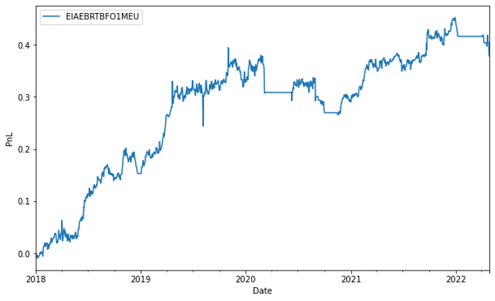

Fig 4.1.1 OLS Model – EIAEBRT-BFO1MEU (Cumulative Profit)

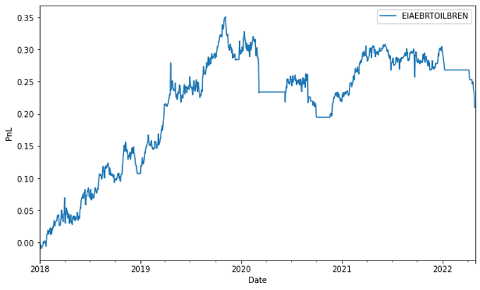

Fig 4.1.2 OLS Model – EIAEBRT-OILBREN (Cumulative Profit)

|  |  |  |  |  |
| --- | --- | --- | --- | --- |
| Pair Name | Cum. Return | Sharpe ratio | Sortino ratio | Max drawdown |
| EIAEBRT-BFO1MEU | 0.378 | 0.755 | 0.068 | 0.126 |
| EIAEBRT-OILBREN | 0.209 | 0.468 | 0.040 | 0.149 |

Table 4.1.1 OLS Model – Performance Metrics

Though the results were not impressive (i.e. low cumulative return and Sharpe ratio), it is noteworthy that these two pairs have consistently been generating profit with low max drawdown. Hence, it is possible to leverage up the pairs to generate more returns, possibly between 5x to 10x. Furthermore, the underlying of both pairs are from the same industry, specifically in crude oil, implying that both pairs are more reliable to trade for fundamental reasoning.

All the remaining pairs either did not generate trade signals or were making losses. This is well within our expectation as the fundamental flaw of this method is to trade on a static hedge ratio.

# Rolling Ordinary Least Squares with Bollinger Bands (R-OLS)

The R-OLS model is an enhanced version of the OLS model. Instead of using 1 set of training periods for trading, R-OLS applies OLS across fixed windows of observations and then rolls (moves or slides) the window across the data set. As a result, every trading day will have a unique hedge ratio value used for each pair. The R-OLS will be applied with Bollinger Bands to decide the entry and exit points.

The R-OLS model will follow trading parameters with the OLS model so that the relative effectiveness of the respective trading models can be compared.

The trading strategy will long/short the spread if it is less/more than 0 standard deviation and stop-loss if the spread is more than the rolling 2 standard deviations. The rolling window is set at 252 days while the timeframe for trading is from 1/1/2018 to 30/4/2022.

From the backtesting, 20 pairs gave positive PnL. For comparing purposes, only EIAEBRT-BFO1MEU and EIAEBRT-OILBREN pairs will be shown.

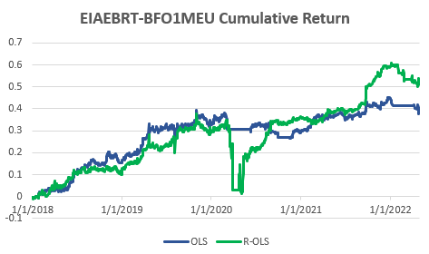

Fig 4.2.1 R-OLS Model – EIAEBRT-BFO1MEU (Cumulative Profit)

Fig 4.2.2 R-OLS Model – EIAEBRT-OILBREN (Cumulative Profit)

|  |  |  |  |  |
| --- | --- | --- | --- | --- |
| Pair Name | Cum. Return | Sharpe ratio | Sortino ratio | Max drawdown |
| EIAEBRT-BFO1MEU  (OLS) | 0.378 | 0.755 | 0.068 | 0.126 |
| EIAEBRT-BFO1MEU  (R-OLS) | 0.537 | 0.674 | 0.053 | 0.333 |
| EIAEBRT-OILBREN  (OLS) | 0.209 | 0.468 | 0.040 | 0.149 |
| EIAEBRT-OILBREN  (R-OLS) | 0.548 | 0.716 | 0.056 | 0.313 |

Table 4.2.1 R-OLS Model – Performance Metrics

From the table above comparing the 2 different models, and the fact that R-OLS produced more pairs with positive PnL, it can be concluded that R-OLS is a better approach. It can adapt to any new changes in the relationship between the pairs and result in better performance.

# Kalman Filter with Bollinger Band

The Kalman Filter is an optimal linear algorithm that updates the expected value of a hidden variable based on the latest value of an observable variable. The hidden variable, in this case, is the hedge ratio of each pair and the observable variables will be one of the components of the pair. Kalman filter works by minimizing the mean squared errors of estimated parameters. It is also a filter because it filters out noise from data to find the best estimate (Lee, 2021).

The reason behind the usage of the Kalman Filter is to reduce the arbitrariness of hedge ratio forecasting that happens with the R-OLS model. With Kalman Filter, there is no need to arbitrarily select the rolling window and the importance of different data points in the selected period (Wang, 2022).

For example, the scatterplot below shows the changes in the relationship between EIAEBRT-OILBREN pairs from 2009 to 2017.

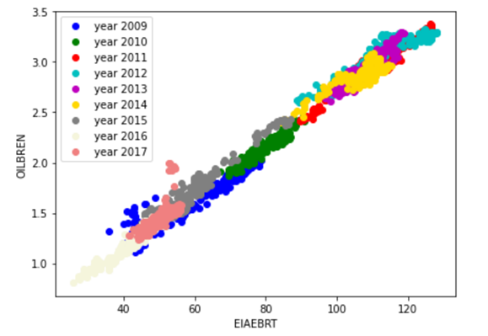

Fig 4.3.1 Kalman Filter – EIAEBRT-BFO1MEU (Relationship)

From the scatter plot, it can be observed that the relationship changes through time. Therefore, the hedge ratio changes over time and any pairs trading strategy should adapt to it.

The diagram below shows how the Kalman Filter slope and intercept throughout the years.

Fig 4.3.2 Kalman Filter – EIAEBRT-BFO1MEU (Intercept)

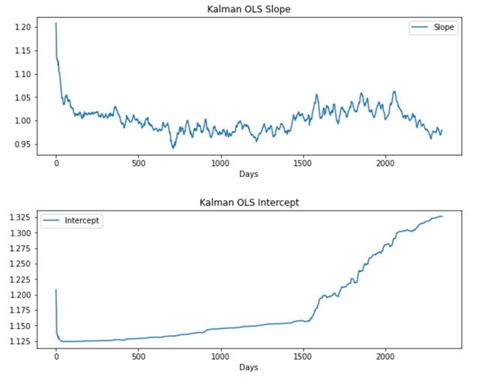

Fig 4.3.3 Kalman Filter – EIAEBRT-BFO1MEU (Slope)

From the diagram, it can be observed that both the intercept and slope are constantly changing. With Kalman Filter, it is possible to get the optimized hedge ratio as it updates the intercept and slope continuously.

The Kalman Filter will be applied with Bollinger Bands to decide the entry and exit points.

The trading strategy will long/short the spread if it is less/more than the rolling 1.5 standard deviation and stop-loss if the spread is more than 5% of allocated capital. The rolling window is set at 125 days while the timeframe for trading is from 1/1/2018 to 30/4/2022.

From the backtesting, 19 pairs gave positive PnL.

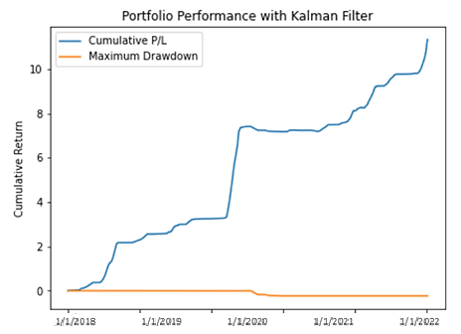

Fig 4.3.4 Kalman Filter Model – Equal Weighted Portfolio (Cumulative Return)

|  |  |  |  |  |
| --- | --- | --- | --- | --- |
| Pair Name | Cum. Return | Sharpe ratio | Sortino ratio | Max drawdown |
| Equal Weighted Portfolio | 9.588 | 0.444 | 7.513 | 0.027 |

Table 4.3.1 Kalman Filter Model – Performance Metrics

Most profitable pairs came from oil and its derivative product. Some profitable unique pairs came from a different group of commodities such as LCPCASH-GOEUARA or LCPCASH-JETCNWE. One reason for this is copper is heavily used in oil and gas processing facilities.

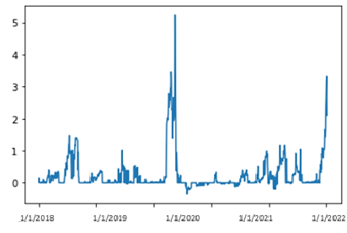

Fig 4.3.5 Kalman Filter Model – Equal Weighted Portfolio (Volatility)

Upon closer inspection of the portfolio volatility, it can be observed that huge volatility in the year 2020 and 2022 that benefited the strategy. The portfolio generated a high potential upside return during volatile times while only faced a few days of losses as seen from the maximum drawdown.

# Support Vector Machine with Markov Regime Switching (SVM)

The idea behind this trading model is to generate dynamic hedge ratios using Support Vector Regression (SVR) for each period that is identified by the Markov Regression as a switch in the regime. After which, a new spread series for each pair using the hedge ratios is computed.

**Markov-Switching Models**

Regime changes can be described as a break (temporarily) between the historic relationship between two assets (i.e. changes in mean and variance), and their spread can deviate significantly from its historical equilibrium leading to a new equilibrium state. There may be a myriad of reasons as to why a temporary regime change occurs, but common reasons include financial crisis, period of economic recession or market crash (e.g. COVID-19 Pandemic).

Traditional pairs trading strategies are unable to detect such ‘regime changes’ which can lead to big losses. Using Markov regime-switching models allows the detection of such changes and adapts the trading rules accordingly. It should also be noted that regime change models differ from structural break models.

Fig 4.4.1 Difference Between Regime Change & Structural Break Models

The Markov-switching model is a popular type of regime-switching model which assumes that unobserved states are determined by an underlying stochastic process known as a Markov-chain. A Markov-chain is a stochastic process used to describe how uncertain and unobserved outcomes occur. In the case of the Markov-switching model, it is used to describe how data falls into unobserved regimes.

A Markov-chain has the property that future states are dependent only on present states (this is known as the Markov property). A key characteristic of a Markov-chain is the transition probabilities. The transition probabilities describe the likelihood that the current regime stays the same or changes (i.e. the probability that the regime transitions to another regime).

**Identifying Regime Changes**

This section will run through the process of identifying regime changes. The pair EIAEBRT-BFO1MEU will be used as an example.

STEP 1: Construct the Spread Ratio

The spread is constructed as a price ratio of the two commodities in the pair (i.e. raw prices of EIABERT divided by raw prices of BFO1MEU, ). Other ways of constructing the spread series or .

The plot of the ratio is as follows:

Fig 4.4.2 Markov Switching Model – EIAEBRT-BFO1MEU (Spread Ratio)

STEP 2: Fitting the Markov Switching Model

The Markov regression can be represented as:

After feeding our spread ratio series into the model and setting the parameters of ‘K_Regimes’ as 2 (i.e. high and low mean regimes) and switching variance as TRUE, the following regression summary is created:

Fig 4.4.3 Markov Switching Model – EIAEBRT-BFO1MEU (Regression Summary)

The coefficient of both the constants refers to the mean in the high and low regime, with the higher value being assigned to the high mean regime.

STEP 3: Plotting the Spread Ratio & Transition Probabilities

With the plots, it is easier to visualize the probability of high-mean regimes. Every time the spread ratio crosse the high mean coefficient of 1.0012, that period is considered the ‘high’ regime.

Fig 4.4.4 Markov Switching Model – EIAEBRT-BFO1MEU (Spread Ratio & Transition Probability)

Naturally, it would be ideal to isolate these dates where the regime switches from one state to another across all pairs. It should be noted that from 27 pairs from our pair selection process, only left with 15 pairs converged using the Markov Regression. The 12 pairs that did not converge were discarded.

|  |  |  |
| --- | --- | --- |
| EIAEBRT-OILBREN | CRUDOIL-NAFCNWE | LCPCASH-GOEUARA |
| EIAEBRT-BFO1MEU | LCPCASH-JETCNWE | WHEATSF-NAFCNWE |
| EIAEBRT-GOEUARA | LCPCASH-LTICASH | WHEATSF-EIANYGR |
| EIAEBRT-EIALALS | PALLADM-LZZCASH | WHEATSF-EIAGCGR |
| EIAEBRT-DIESELA | LNICASH-RHODNWE | WHEATSF-NATBGAS |

Table 4.4.1 Markov Regression Trading Pairs

Fig 4.4.5 Markov Switching Model – Regime Periods (Not Full List)

**Support Vector Machine**

For every single regime period, SVM is used to generate the respective hedge ratio. SVM is chosen because it demonstrates superior performance as compared to OLS (Baek, Glambosky, Oh and Lee, 2020). While linear regression models minimize the error between the actual and predicted values through the line of best fit, SVM manages to fit the best line within a threshold of values, otherwise called the epsilon-insensitive tube.

Fig 4.4.6 Difference Between SVM & OLS

Fig 4.4.5 Markov Switching Model – Hedge Ratio

The spread for each pair across the entire sample period is based on the generated hedge ratios:

*where ‘a’ and ‘b’ are prices of futures A and B respectively and n is the hedge ratio*

Fig 4.4.6 Markov Switching Model – Pair Spread

**Backtesting**

The trading strategy will long/short the spread if the rolling mean it is less/more than the spread rolling standard deviation. The rolling window is set at 42 days while the timeframe for trading is from 1/1/2008 to 30/4/2022.

From the backtesting, 11 pairs gave positive PnL.

**

Fig 4.4.7 Markov Switching Model – Equal Weighted Portfolio (Cumulative Return)

|  |  |  |  |  |
| --- | --- | --- | --- | --- |
| Pair Name | Cum. Return | Sharpe ratio | Sortino ratio | Max drawdown |
| Equal Weighted Portfolio | 6.850 | 0.583313 | - | 0.519068 |

Table 4.3.1 Kalman Filter Model – Performance Metrics

# Reference

Harlacher, M. (2016). Cointegration based algorithmic pairs trading. PhD thesis, University of St. Gallen.

Sarmento, S. M., & Horta, N. (2020). Enhancing a pairs trading strategy with the application of machine learning. Expert Systems with Applications, 158, 113490. https://doi.org/10.1016/j.eswa.2020.113490

Baek, Seungho, Mina Glambosky, Seok H. Oh, and Jeong Lee. (2020). Machine Learning and Algorithmic Pairs Trading in Futures Markets. Sustainability 12, no. 17: 6791. https://doi.org/10.3390/su12176791

Lee, O. (2021). Kalman Filters In Pairs Trading. Medium. Retrieved 25 June 2022, from https://medium.datadriveninvestor.com/kalman-filters-in-pairs-trading-dcf98a91a808.

Wang, L. (2022). Kalman Filter and Pairs Trading. Quantitative Trading and Systematic Investing. Retrieved 25 June 2022, from https://letianzj.github.io/kalman-filter-pairs-trading.html.

# Appendix

**List of Commodity Futures**

|  |  |  |  |  |
| --- | --- | --- | --- | --- |
| **No** | **Name** | **Type** | **Sub-Type** | **Ticker** |
| 1 | Steel Iron ore Fe62% AUS CIF China | Metal | Steel | SHCNI62 |
| 2 | Steel Iron ore Fe65% BR CIF China | Metal | Steel | SHCNI58 |
| 3 | LME-Copper Grade A Cash U$/MT | Metal | Non-Ferrous Metal | LCPCASH |
| 4 | LME-Nickel Cash U$/MT | Metal | Non-Ferrous Metal | LNICASH |
| 5 | LME-NASAAC Cash U$/MT | Metal | Non-Ferrous Metal | LNACASH |
| 6 | LME-Aluminium 99.7% Cash U$/MT | Metal | Non-Ferrous Metal | LAHCASH |
| 7 | LME-Aluminium Alloy Cash U$/MT | Metal | Non-Ferrous Metal | LADCASH |
| 8 | LME-SHG Zinc 99.995% Cash U$/MT | Metal | Non-Ferrous Metal | LZZCASH |
| 9 | LME-Tin 99.85% Cash U$/MT | Metal | Non-Ferrous Metal | LTICASH |
| 10 | LME-Lead Cash U$/MT | Metal | Non-Ferrous Metal | LEDCASH |
| 11 | Rhodium CIF NWE U$/Ounce | Metal | Precious Metals | RHODNWE |
| 12 | Gold Bullion LBM $/t oz DELAY | Metal | Precious Metals | GOLDBLN |
| 13 | Silver, Handy&Harman (NY) U$/Troy OZ | Metal | Precious Metals | SILVERH |
| 14 | Palladium U$/Troy Ounce | Metal | Precious Metals | PALLADM |
| 15 | London Platinum Free Market $/Troy oz | Metal | Precious Metals | PLATFRE |
| 16 | Gold, Handy & Harman Base $/Troy Oz | Metal | Precious Metals | GOLDHAR |
| 17 | Ethanol, Spot NY Harbour U$/GAL | Chemical | Ethanol | ETHANYH |
| 18 | DAP, New Orleans CFR Barge U$/MT | Chemical | Fertilizer | DAPNOCB |
| 19 | Urea Granular CFR New Orleans $/MT | Chemical | Fertilizer | UREAGRN |
| 20 | USGC GLN REG Spt Price FOB U$/GAL | Energy | Gas | EIAGCGR |
| 21 | NY Conv GLN REG Spt Price FOB U$/GAL | Energy | Gas | EIANYGR |
| 22 | ICE Natural Gas 1 Mth.Fwd. P/Therm | Energy | Gas | NATBGAS |
| 23 | Crude Oil WTI NYMEX Close M U$/BBL | Energy | Crude Oil | OILWTXI |
| 24 | Crude Oil North Sea BFO FOB U$/BBL | Energy | Crude Oil | CRUDBFO |
| 25 | Crude Oil BFO M1 Europe FOB $/Bbl | Energy | Crude Oil | BFO1MEU |
| 26 | Crude Oil WTI FOB Cushing U$/BBL | Energy | Crude Oil | CRUDWTC |
| 27 | Crude Oil-WTI Spot Cushing U$/BBL | Energy | Crude Oil | CRUDOIL |
| 28 | Europe Brent Spot FOB U$/BBL Daily | Energy | Crude Oil | EIAEBRT |
| 29 | Crude Oil BFO M1 Europe FOB $/BBl | Energy | Crude Oil | OILBREN |
| 30 | Gasoil, 0.2% Sulphur FOB ARA U$/MT | Energy | Fuel Oil | GOEUARA |
| 31 | Fuel Oil No.2 (New York) C/Gallon | Energy | Fuel Oil | FUELOIL |
| 32 | NY No. 2 HO Spt Price FOB U$/GAL | Energy | Heating Oil | EIANYHO |
| 33 | Diesel, .05% Sulphur LA C/GAL | Energy | Diesel | DIESELA |
| 34 | SNL US Electricity Peak load SP-15 | Energy | Electricity | ES15PSN |
| 35 | EEX - Phelix Peak Hr.09-20 E/Mwh | Energy | Electricity | EEXPEAK |
| 36 | Electricity PJM Base Rate U$/MWh | Energy | Electricity | ELEPJMB |
| 37 | Electricity PJM Peak Rate U$/MWh | Energy | Electricity | ELEPJMP |
| 38 | EEX - Phelix Base Hr.01-24 E/Mwh | Energy | Electricity | EEXBASE |
| 39 | USGC KERO Jet Spt Price FOB U$/GAL | Energy | Jetfuel | EIAUSGJ |
| 40 | Jet Kerosene CIF NWE U$/MT | Energy | Jetfuel | JETCNWE |
| 41 | Jet Kerosene FOB Singapore U$/BBL | Energy | Jetfuel | JETFSIN |
| 42 | LA ULSD CARB Spot Price U$/GAL | Energy | Sulphur | EIALALS |
| 43 | NY ULSD No. 2 Spot Price U$/GAL | Energy | Sulphur | EIANYLS |
| 44 | USGC ULSD No. 2 Spot Price U$/GAL | Energy | Sulphur | EIAGCLS |
| 45 | Naphtha 2 Half Tokyo Near M C+F $/MT | Energy | Naphtha | NAF2HTY |
| 46 | Naphtha, FOB Singapore U$/BBL | Energy | Naphtha | NAFSING |
| 47 | Naphtha, CIF NWE U$/MT | Energy | Naphtha | NAFCNWE |
| 48 | Mont Belvieu TX Prop Spt FOB U$/GAL | Energy | Propane | EIATXPR |
| 49 | Yellow Soybn US NO.1 Sth Dvprt U$/Bsh | Agriculture | Soy | SOYADSC |
| 50 | Soya Oil, Crude Decatur US $/lb | Agriculture | Soy | SOYAOIL |
| 51 | Soyameal USA 48% Protein $/MT | Agriculture | Soy | SOYMUSA |
| 52 | Soyabeans, No.1 Yellow $/Bushel | Agriculture | Soy | SOYBEAN |
| 53 | Soymeal 48% FOB K.City $/MT | Agriculture | Soy | SOYMKCT |
| 54 | Corn No.2 Yellow U$/Bushel | Agriculture | Corn | CORNUS2 |
| 55 | Corn US No.2 South Central IL $/BSH | Agriculture | Corn | COTSCIL |
| 56 | Wheat US HRS 14% Del Mineapolis/Dulut | Agriculture | Wheat | WHTHRMD |
| 57 | Wheat No.2,Soft Red U$/Bu | Agriculture | Wheat | WHEATSF |
| 58 | Rice, White 100% FOB Bangkok U$/MT | Agriculture | Rice | WSUGDLY |
| 59 | Milk Non Fat Dry Grade A Spot | Agriculture | Milk | MILKGDA |
| 60 | Live Steers, USDA 5 Area Wtd. Avge. | Agriculture | Steers | USTEERS |
| 61 | HOG 51-52% US 3 AREA Ntnl MR U$/Cwt | Agriculture | Hog | HOGNTMR |
| 62 | Wool AWEX E.M.I. A$/100KG | Agriculture | Wool | WOLAWCE |
| 63 | Palm Kernel Oil MAL CIF Rdam US$ /MT | Agriculture | Palm Oil | PAOLMAL |
| 64 | Raw Sugar-ISA Daily Price c/lb | Agriculture | Sugar | WSUGDLY |
| 65 | Cocoa-ICCO Daily Price US$/MT | Agriculture | Cocoa | COCINUS |
| 66 | Cotton,1 1/16Str Low -Midl,Memph $/Lb | Agriculture | Cotton | COTTONM |

Table A.1 List of Commodity Futures

**List of Final Trading Pairs**

|  |  |  |  |
| --- | --- | --- | --- |
| **No** | **Leg1** | **Leg2** | **Trading Pairs** |
| 1 | EIAEBRT | OILBREN | EIAEBRT-OILBREN |
| 2 | EIAEBRT | EIAUSGJ | EIAEBRT-EIAUSGJ |
| 3 | EIAEBRT | BFO1MEU | EIAEBRT-BFO1MEU |
| 4 | EIAEBRT | GOEUARA | EIAEBRT-GOEUARA |
| 5 | EIAEBRT | EIALALS | EIAEBRT-EIALALS |
| 6 | EIAEBRT | EIANYHO | EIAEBRT-EIANYHO |
| 7 | EIAEBRT | EIANYLS | EIAEBRT-EIANYLS |
| 8 | EIAEBRT | EIAGCLS | EIAEBRT-EIAGCLS |
| 9 | EIAEBRT | DIESELA | EIAEBRT-DIESELA |
| 10 | EIAEBRT | FUELOIL | EIAEBRT-FUELOIL |
| 11 | CRUDOIL | OILWTIN | CRUDOIL-OILWTIN |
| 12 | CRUDOIL | NAFCNWE | CRUDOIL-NAFCNWE |
| 13 | CRUDOIL | CRUDWTC | CRUDOIL-CRUDWTC |
| 14 | CRUDOIL | ETHANYH | CRUDOIL-ETHANYH |
| 15 | CRUDOIL | EIANYGR | CRUDOIL-EIANYGR |
| 16 | CRUDOIL | EIAGCGR | CRUDOIL-EIAGCGR |
| 17 | CRUDOIL | OILWTXI | CRUDOIL-OILWTXI |
| 18 | GOLDBLN | GOLDHAR | GOLDBLN-GOLDHAR |
| 19 | LCPCASH | JETCNWE | LCPCASH-JETCNWE |
| 20 | LCPCASH | LTICASH | LCPCASH-LTICASH |
| 21 | PALLADM | LZZCASH | PALLADM-LZZCASH |
| 22 | LNICASH | RHODNWE | LNICASH-RHODNWE |
| 23 | LCPCASH | GOEUARA | LCPCASH-GOEUARA |
| 24 | WHEATSF | NAFCNWE | WHEATSF-NAFCNWE |
| 25 | WHEATSF | EIANYGR | WHEATSF-EIANYGR |
| 26 | WHEATSF | EIAGCGR | WHEATSF-EIAGCGR |
| 27 | WHEATSF | NATBGAS | WHEATSF-NATBGAS |

Table A.2 List of Final Trading Pairs